1. **Hold the ESC key and connect the keyboard with your computer. Or you can hold the button behind the PCB and connect the PCB with your computer via USB-C cable.**

**Do not release the ESC key or the PCB button until you can see the a device called *STM 32 BOOTLOADER* appearing in your computer settings (Bluetooth and other devices section).**

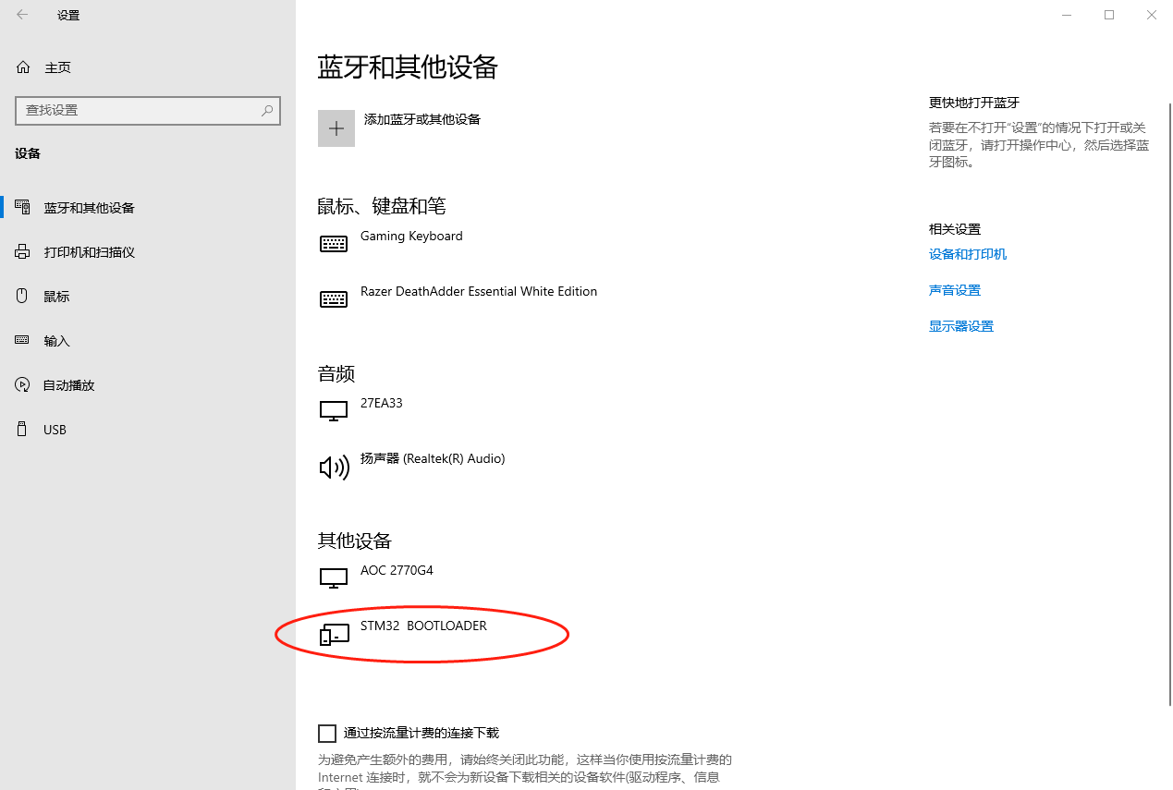

1. **Open the QMK Toolbox**

1. **Select the firmware you want to flash**

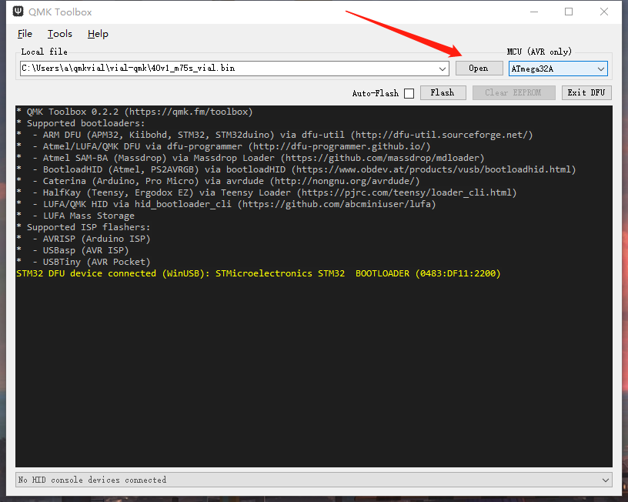

1. **Click *Flash* and wait until the flash finishes.**

1. **Finished.** 图片包含 形状

   描述已自动生成

Chinese Version:

1. 按住esc键重新上电或按住PCB背后的按键重新上电,直到  
   

这里显示STM３２　ＢＯＯＴＬＯＡＤＥＲ

1. 打开 QMK Toolbox

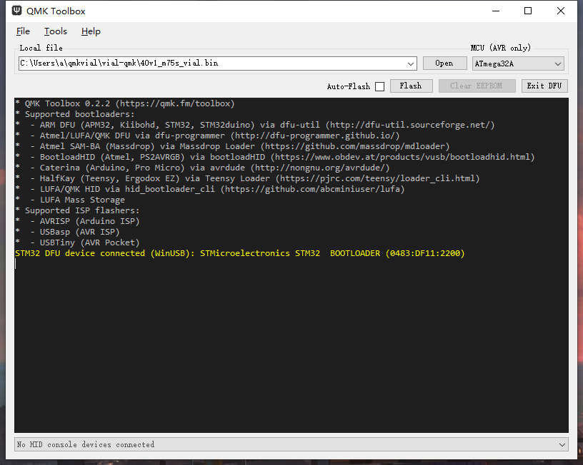

３．选择你需要下载的固件  


４.下载

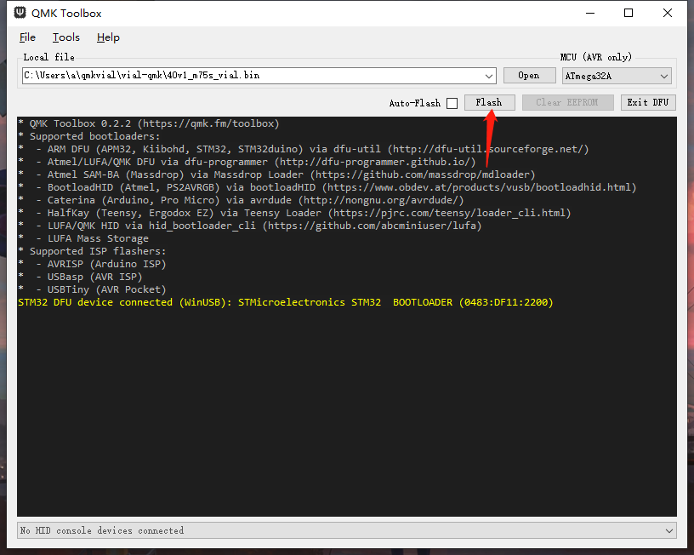

1. 等待完成  
   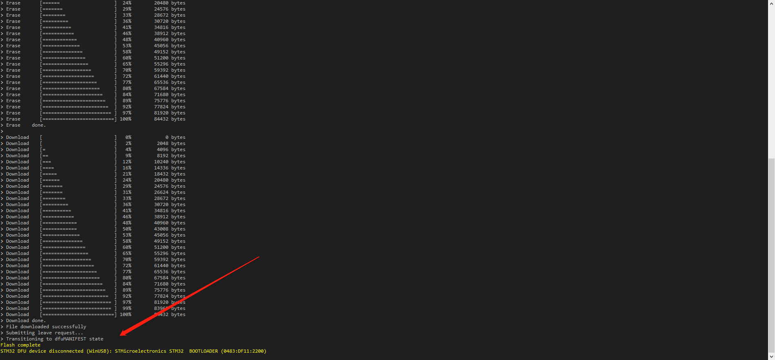

等待完成即可